9.4: a) 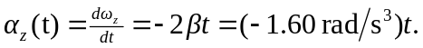

b)

which is half as large (in magnitude) as the acceleration at 